Computer Programming  
Lab Tasks



Department of Computer Science - BUIC

Name: Saad Ahmad

Enrollment Number: 01-134222-130

**Exercises/Lab Journal 7**

**Task 1**.

Write a program that sorts following arrays using bubble sort.

|  |  |  |  |  |  |  |  |  |
| --- | --- | --- | --- | --- | --- | --- | --- | --- |
| 3 | 1 | 4 | 1 | 5 | 9 | 2 | 6 | 5 |

|  |  |  |  |  |  |  |
| --- | --- | --- | --- | --- | --- | --- |
| 2 | 10 | 14 | 11 | 13 | 82 | 4 |

|  |  |  |  |  |  |  |  |  |  |  |
| --- | --- | --- | --- | --- | --- | --- | --- | --- | --- | --- |
| 1 | 3 | 4 | 9 | 7 | 2 | 22 | 31 | 13 | 22 | 11 |

Your program should follow the sequence of actions given below.

* Declare and initialize the three arrays
* Sort first array, print the sorted array
* Sort second array, print the sorted array
* Sort third array, print the sorted array
* Identify Median value of each array and display it.

**Code:**

#include <iostream>

using namespace std;

int main() {

int array1[] = { 3,1,4,1,5,9,2,6,5};

int array2[] = { 2,10,14,11,13,82,4 };

int array3[] = { 1,3,4,9,7,2,22,31,13,22,11 };

int x = sizeof(array1) / sizeof(int);

int y = sizeof(array2) / sizeof(int);

int z = sizeof(array3) / sizeof(int);

int temp;

int i;

int n;

for (i = 0; i < x; i++) {

for (n = 0; n < x-1; n++) {

if (array1[n] > array1[n + 1]) {

temp = array1[n];

array1[n] = array1[n + 1];

array1[n + 1] = temp;

}

}

}

for (i = 0; i < x; i++) {

cout << array1[i] << " ";

}

for (i = 0; i < y; i++) {

for (n = 0; n < y - 1; n++) {

if (array2[n] > array2[n + 1]) {

temp = array2[n];

array2[n] = array2[n + 1];

array2[n + 1] = temp;

}

}

}

cout << endl;

for (i = 0; i < y; i++) {

cout << array2[i] << " ";

}

for (i = 0; i < z; i++) {

for (n = 0; n < z - 1; n++) {

if (array3[n] > array3[n + 1]) {

temp = array3[n];

array3[n] = array3[n + 1];

array3[n + 1] = temp;

}

}

}

cout << endl;

for (i = 0; i < z; i++) {

cout << array3[i] << " ";

}

cout << endl;

//Array median values

int median;

if (x % 2 != 0) {

median = (x + 1) / 2;

cout <<"Median value of Array1 : " << array1[median - 1] << endl;

}

if (y % 2 != 0) {

median = (y + 1) / 2;

cout << "Median value of Array2 : " << array2[median - 1] << endl;

}

if (z % 2 != 0) {

median = (z + 1) / 2;

cout << "Median value of Array3 : " << array3[median - 1];

}

return 0;

}

**Output:**

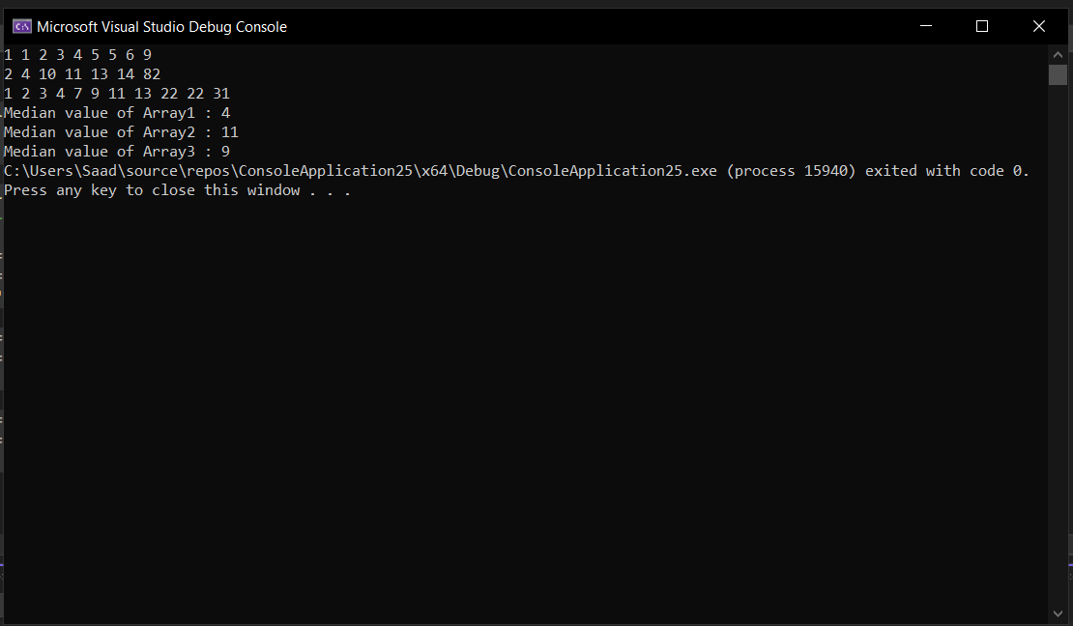

**Task 2.**

Write a program that finds out if a value given by user is present in an array or not, you can use linear search or binary search for this problem.

|  |  |  |  |  |  |  |  |  |
| --- | --- | --- | --- | --- | --- | --- | --- | --- |
| 12 | 16 | 4 | 0 | 52 | 93 | 22 | 64 | 50 |

**Code:**

#include <iostream>

using namespace std;

int main() {

int arr[]{ 12,16,4,0,52,93,22,64,50 };

int check, i;

int found = 0;

cout << "Enter the number you want to check : " << endl;

cin >> check;

for (i = 0; i < size(arr); i++) {

if (arr[i] == check) {

cout << arr[i] << " is present at " << i;

found++;

}

}

if (found == 0) {

cout << "This number is not present in the array";

}

return 0;

}

**Output:**

